**Secrets Manager Python Scripts**

* **CSV File Setup**

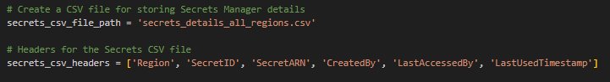

The script starts by defining the file path (secrets_details_all_regions.csv) where the Secrets Manager details will be stored.

The headers for the CSV file are defined: Region, SecretID, SecretARN, CreatedBy, LastAccessedBy, LastUsedTimestamp.

* **CSV File Creation and Headers Writing**

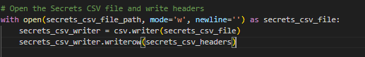

The script opens the CSV file in write mode using open.

A CSV writer is initialized, and the headers are written to the file.

* **Fetch AWS Regions**

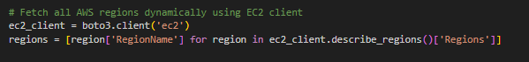

It uses the Boto3 library to create an EC2 client.

It retrieves a list of AWS regions dynamically by querying the EC2 client.

* **Secrets Manager Client Initialization**

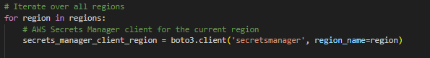

It iterates over each AWS region.

For each region, it creates an AWS Secrets Manager client using boto3.client('secretsmanager', region_name=region).

* **Secrets Iteration**

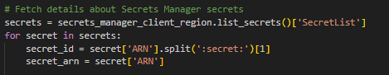

It fetches details about Secrets Manager secrets in the current region using list_secrets.

It iterates over each secret and extracts relevant information like secret_id and secret_arn from the secret's ARN.

* **CloudTrail Events for Secret Creation**

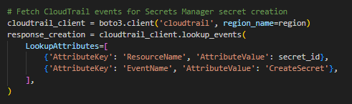

It creates a CloudTrail client for the current region.

It uses lookup_events to fetch CloudTrail events related to the creation of the current secret.

* **Extracting Creator's Identity**

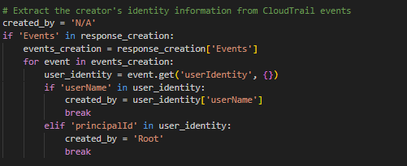

It checks if there are CloudTrail events for secret creation.

It iterates over the events and extracts the creator's identity information. If a username is found, it is assigned to created_by. If not, it defaults to 'Root'.

* **CloudTrail Events for Secret Access**

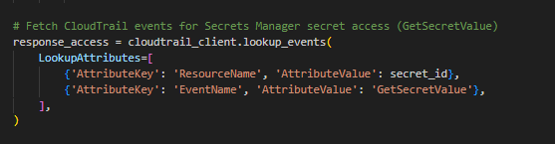

It fetches CloudTrail events related to access (specifically, GetSecretValue) for the current secret.

* **Extracting Last Accessed Time and Username**

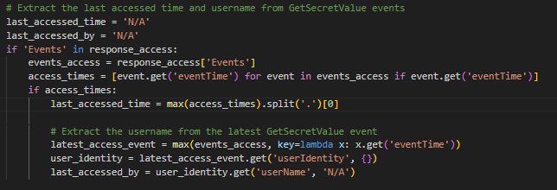

It checks if there are CloudTrail events for secret access.

If access events are found, it extracts the last accessed time and username from the latest GetSecretValue event.

* **Write Data to CSV**



It writes the gathered information (region, secret_id, secret_arn, created_by, last_accessed_by, last_accessed_time) for the current secret to the CSV file.

* **Completion Message**



It prints a message indicating that the Secrets CSV file has been generated.

* **Output**

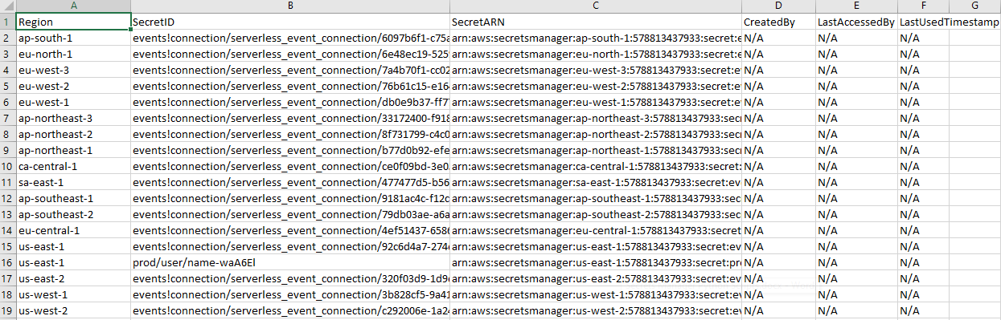

* **Missing Fields Explanation**

1. Creator Information:

AWS Secrets Manager Limitation: Unfortunately, AWS Secrets Manager itself does not provide direct information about who created a secret through its API.

1. Workaround:

The script uses AWS CloudTrail events to attempt to determine the creator. However, it's important to note that AWS CloudTrail events may not always contain detailed information, especially regarding the creator's IAM username. The events may lack this information due to the nature of certain AWS services or automated processes.

1. Last Access Information:

Limitation in Secrets Manager API: Similar to the creator information, AWS Secrets Manager does not provide a direct API call to get the last accessed timestamp or information about who accessed the secret.

CloudTrail Events for Access: The script uses CloudTrail events with the GetSecretValue operation to identify the last time the secret was accessed. However, not all access events might be captured due to the limitations of CloudTrail or the specific configuration of AWS environment.

1. Security and Privacy:

Secret Manager services prioritize the security and privacy of sensitive information. Storing access and creation details within the service itself could potentially expose sensitive information or compromise security. Therefore, this type of information is often managed at a higher level in the cloud platform's infrastructure.

1. Scalability and Performance:

To ensure scalability and performance, Secret Manager services might prioritize the efficiency of secret storage and retrieval operations. Recording detailed logs for every action could impact the performance and scalability goals of the service.